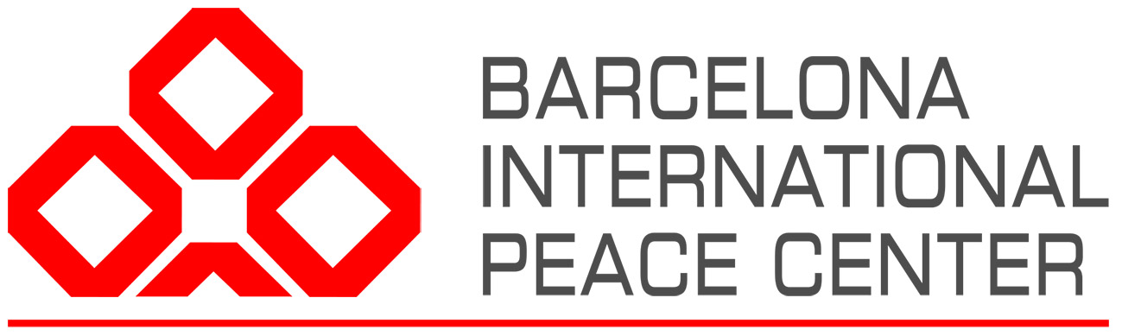

COMMUNITY BASED (RE)INTEGRATION AND SECURITY TRAINING COURSE FOR PRACTITIONERS
Depending on COVID-19 travel restrictions, planned for the 20th to the 27th of June 2021, Barcelona, Spain

APPLICATION FORM
DEADLINE: 1st February 2021
Please complete ALL sections of the application form and remember to attach your CV.
If you have any questions email the training team at info@bcnpeacecenter.org cc-ed to operations@transitioninternational.com

SECTION 1: PERSONAL DETAILS
First Name: | Family Name:
Gender: | Date of Birth:
Nationality: | Country of Residence:
Will you need a visa to attend this course?  Yes / No  If yes. at which consulate will you apply: | Current job at Organisation:  Title of post:  Level:  (especially for UN, write your P-level)
E-mail: | Address:
Phone number(s): | Contact person in case of emergency:

SECTION 2: HEALTH & DIETARY REQUIREMENTS
Health Requirements: Please list any health conditions we should know about | Dietary Requirements: Please list any dietary requirements you have

SECTION 2: PLEASE ANSWER THE FOLLOWING QUESTIONS. THIS WILL FORM THE BASIS OF OUR ASSESSMENT OF YOUR APPLICATION AND WILL FURTHER INFORM OUR ADAPTATION OF THE COURSE
Have you attended any courses in (re)integration or related fields? Please give details of the length of the course, who ran it and where it was held.

Do you have any previous experience of working in (re)integration? Please give us details of which type of (re)integration work you have been involved in – ex-combatants, IDPs, refugees, migrants, children etc.

Please give details of any other relevant field experience in conflict or post-conflict settings.

Why do you want to attend this particular course?

What precisely would you like to learn from this course?

How will you make use of what you learn from this course? Where and for whom do you expect to engage in (Re)integration work in the future?

What will you bring to this course? Is there any topic you would like to co-train on during the course (not obligatory)?

SECTION 4: LANGUAGE | How did you hear about the course?
Please describe your level of English on a scale of 1-5 where 1 is basic and 5 is fluent/mother tongue:

Speaking ________ Writing ________ Listening ________

I have read and agree to the Application and payment Terms & Conditions of the training course. (Please read these terms and conditions carefully before applying).

Signature: Date:

PLEASE REMEMBER TO ATTACH YOUR CV & RETURN TO
info@bcnpeacecenter.org with CC to kim@transitioninternational.com
DEADLINE FOR RECEIPT OF APPLICATIONS: 1st of February 2021
Please note we are accepting on a rolling basis – so apply ASAP

The course fee is 2000 Euro.

The course will be held in Barcelona, Spain*
* possible change of location if needed in the light of the COVID-19 situation and the public health recommendations.

Participants must cover their own accommodation, meals (lunch is provided), travel, and medical insurance costs

